Ex.no:2 | EDA-Data Import and Export

Aim:

Algorithm:

Program:
# Import required libraries
import pandas as pd
import sqlite3

# Load the Diabetes Dataset
df = pd.read_csv("diabetic_data.csv",na_values="?",low_memory=False)

# Display complete dataset
print("===== DATASET =====")
print(df)

# Display first five records
print("\n===== FIRST FIVE ROWS =====")
print(df.head())

# Display last five records
print("\n===== LAST FIVE ROWS =====")
print(df.tail())

# Display dataset information
print("\n===== DATASET INFORMATION =====")
print(df.info())

# Display statistical summary
print("\n===== STATISTICAL SUMMARY =====")
print(df.describe(include="all"))

# Display dataset shape
print("\nDataset Shape:")
print(df.shape)

# Display column names
print("\n===== COLUMN NAMES =====")
print(df.columns)

# Check missing values
print("\n===== MISSING VALUES =====")
print(df.isnull().sum())

# Export dataset to CSV
df.to_csv( "diabetic_data_export.csv",index=False)
print("\nCSV file exported successfully!")

# Export dataset to Excel
df.to_excel("diabetic_data_export.xlsx",index=False)
print("Excel file exported successfully!")

# Create SQLite Database
conn = sqlite3.connect("diabetes_dataset.db")

# Export DataFrame to SQL Table
df.to_sql("diabetic_data",conn,if_exists="replace",index=False)
print("Dataset exported successfully to SQLite Database!")
conn.close()
Output:

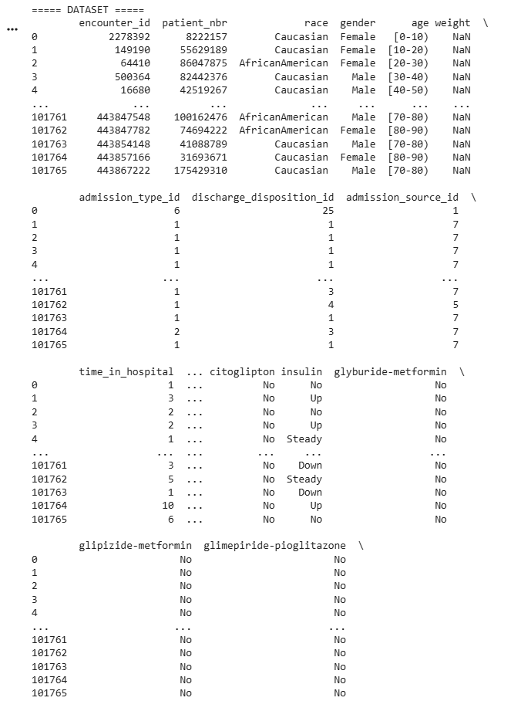

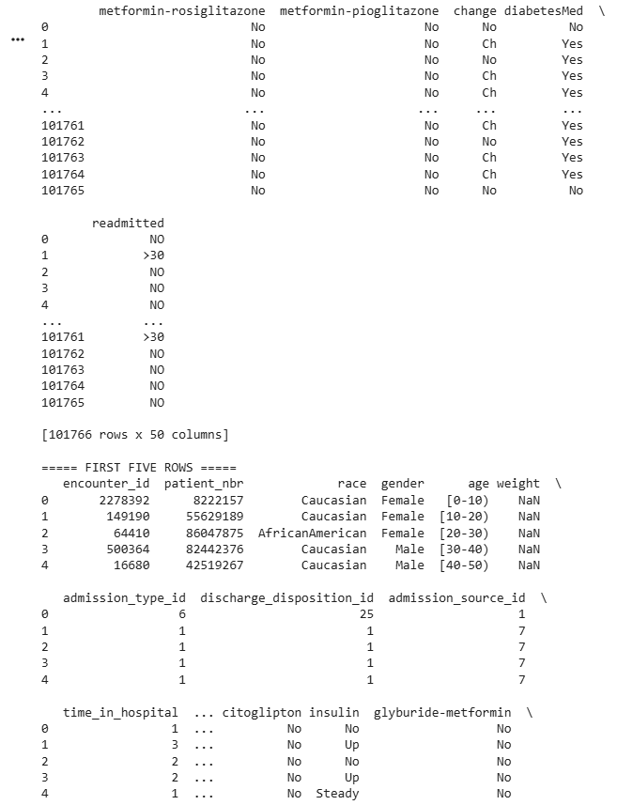

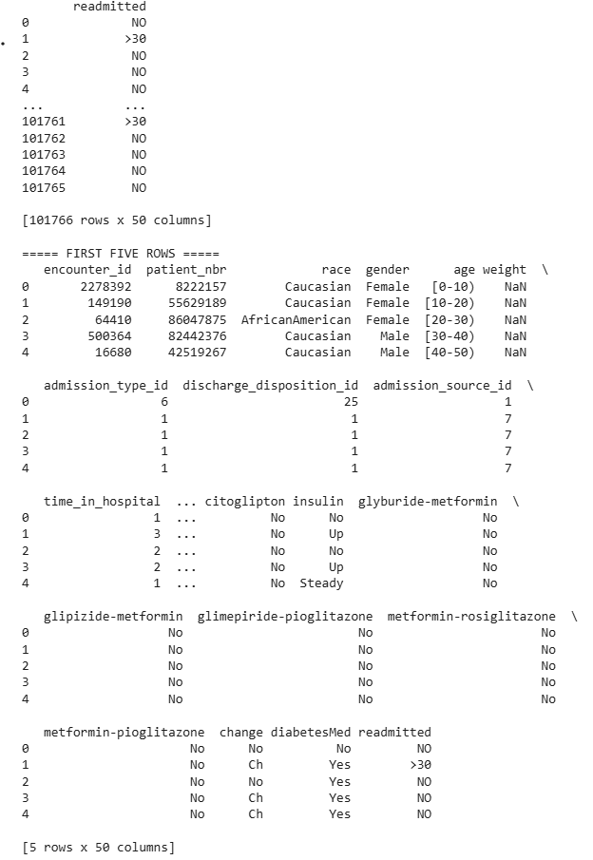

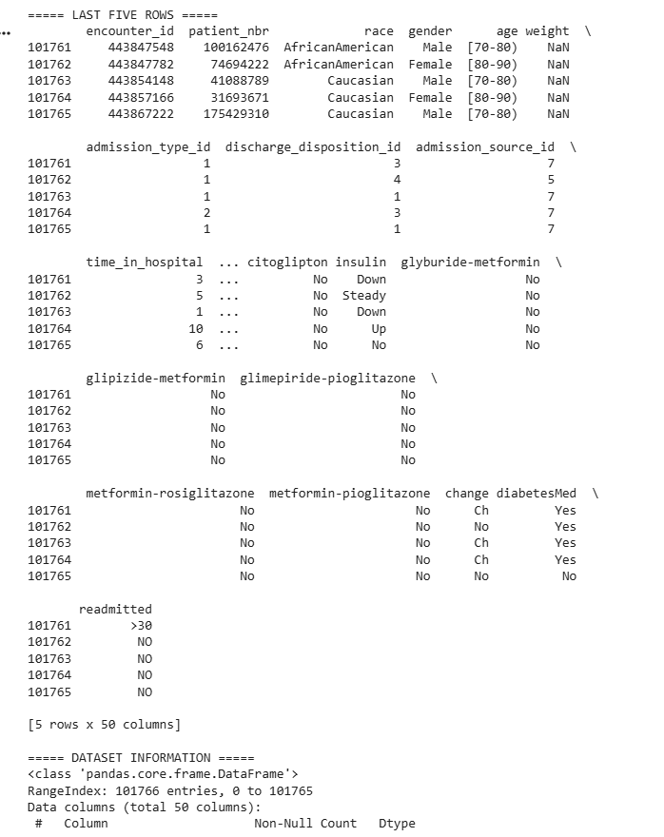

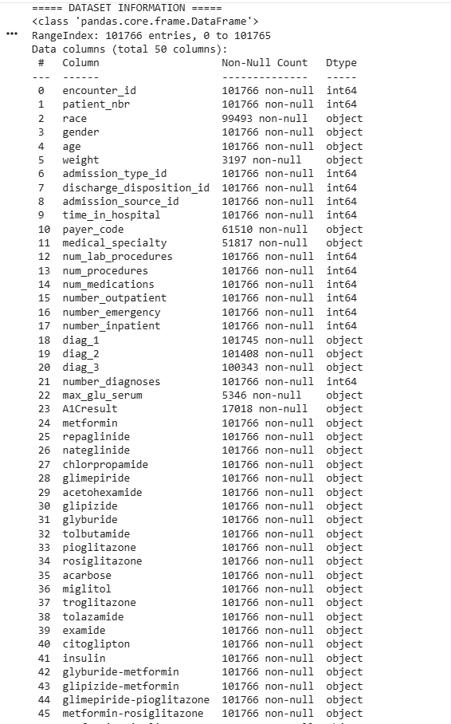
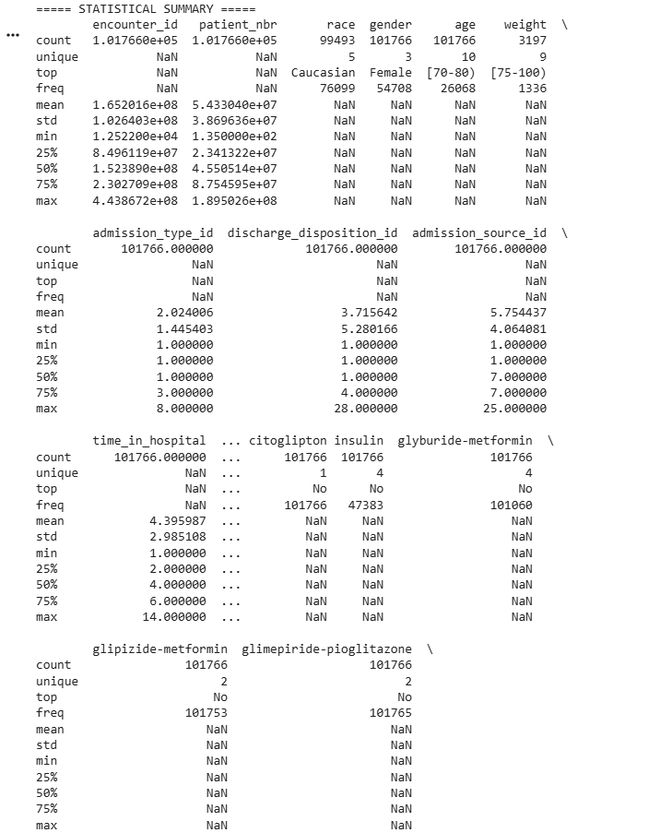

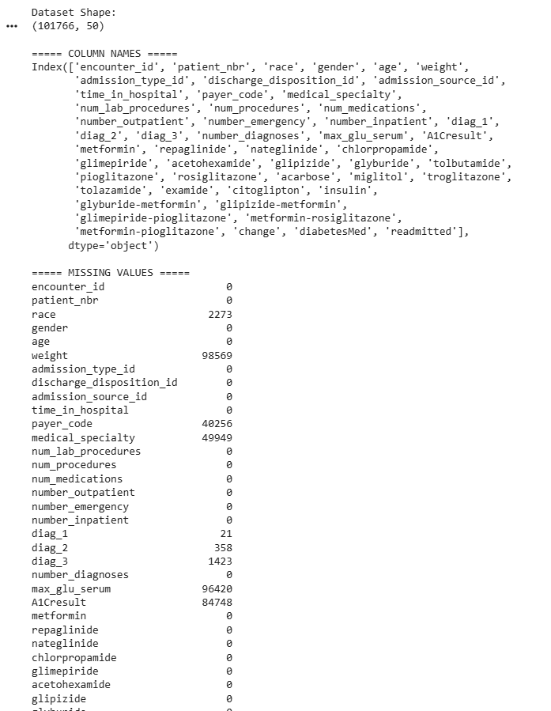
Result:

